MOVIE RECOMMENDATION SYSTEM USING PYTHON DJANGO
MINI PROJECT REPORT

Name:T.Lavanya
Roll Number:23AK1A0455
Department:ECE
College Name:Annamacharya Institute of Technology and Sciences,Tirupathi

CERTIFICATE
This is to certify that T.Lavanya (23AK1A0455),Department of ECE,has successfully completed the mini project titled ‘Movie Recommendation System Using Python Django’ as part of the academic curriculum.
ABSTRACT
The Movie Recommendation System is a web-based application developed using Python, Django, HTML, CSS, and SQLite. It helps users explore and discover movies by providing movie details, categories, and recommendations through a simple and user-friendly interface. The system includes user login and admin management features for maintaining movie data. This project demonstrates the use of web development technologies to create an efficient platform for movie browsing and recommendation
INTRODUCTION
The Movie Recommendation System is a web-based mini project developed using Python and Django that helps users find movies based on their interests and preferences. The system stores movie information such as title, genre, and ratings in a database and provides recommendations of similar movies. It offers a simple and user-friendly interface, making it easier for users to discover and select movies they may enjoy.
OBJECTIVES
The main objective of the Movie Recommendation System is to develop a user-friendly web application using Python and Django that helps users discover movies based on their interests and preferences. The system aims to manage movie information efficiently, provide personalized recommendations, and enhance the user experience by making movie searching and selection easier and faster.
TECHNOLOGIES USED

- Python Backend
- HTML front end
- Django Wed Framework
- CSS Styling
- SQLite Database
- VS Code Development tool

SYTEM REQUIREMENT
Hardware
Processor: Intel i3 or above
RAM: 4 GB
Storage: 20 GB
Software
Windows 10/11
Python
Django
VS Code
SYSTEM DESIGN
HOME PAGE
<!DOCTYPE html>
<html>
<head>
<title>Movie Recommendation System</title>
<style>
body{
margin:0;
}
::-webkit-scrollbar{
height:8px;
}
::-webkit-scrollbar-thumb{
background:red;
border-radius:10px;
}
</style>
</head>
<body style="background:#141414; color:rgb(255, 255, 255); font-family:Arial;">
<!-- STEP 1: TITLE -->
<h1 style="text-align:center; margin-top:23px; color:#e50914">
🎬 Movie Recommendation System
</h1>
<!-- STEP 2: NAVBAR (sticky added here) -->
<div style="
background:#111;
padding:15px;
display:flex;
gap:20px;
align-items:center;
margin-top: 8px;
position:sticky;
top:0;
z-index:1000;
box-shadow: 0 2px 10px rgba(0,0,0,0.6);
backdrop-filter: blur(10)
<a href="/"
style="color:white; text-decoration:none;"
onmouseover="this.style.color='red'"
onmouseout="this.style.color='white'">
All
</a>
<a href="/?type=recommended"
style="color:white; text-decoration:none;"
onmouseover="this.style.color='red'"
onmouseout="this.style.color='white'">
Recommended
</a>
<a href="/?type=top"
style="color:white; text-decoration:none;"
onmouseover="this.style.color='red'"
onmouseout="this.style.color='white'">
Top Rated
</a>
<a href="/?type=thriller"
style="color:white; text-decoration:none;"
onmouseover="this.style.color='red'"
onmouseout="this.style.color='white'">
Thriller
</a>
<a href="/?type=comedy"
style="color:white; text-decoration:none;"
onmouseover="this.style.color='red'"
onmouseout="this.style.color='white'">
Comedy
</a>
<a href="/?type=action"
style="color:white; text-decoration:none;"
onmouseover="this.style.color='red'"
onmouseout="this.style.color='white'">
Action
</a>
<form method="GET" style="margin-left:auto;">
<input
type="text"
name="q"
placeholder="Search movies"
style="
padding:8px;
border-radius:5px;
border:none;
outline:none;
">
<button
type="submit"
style="
padding:8px 12px;
background:red;
color:white;
border:none;
border-radius:5px;
cursor:pointer;
">
Search
</button>
</form>
<div style="display:flex; align-items:center; background:#111; padding:15px;">
<!-- LEFT SIDE MENU -->
<a href="/" style="color:white; margin-right:15px;">Home</a>
<!-- RIGHT SIDE -->
<div style="margin-left:auto; display:flex; gap:15px; align-items:center;">
{% if user.is_authenticated %}
<!-- ACCOUNT SECTION -->
<span style="color:white;">
👤 {{ user.username }}
</span>
<!-- LOGOUT -->
<a href="/logout/" style="
background:red;
color:white;
padding:6px 12px;
border-radius:5px;
text-decoration:none;">
Logout
</a>
{% else %}
<!-- LOGIN -->
<a href="/login/" style="color:white;">Login</a>
<!-- SIGNUP -->
<a href="/signup/" style="
background:red;
color:white;
padding:6px 12px;
border-radius:5px;
text-decoration:none;">
Signup
</a>
{% endif %}
</div>
</div>
</div>
<h3 style="padding:20px 20px 10px 20px;">
⭐ Featured Movies
</h3>
<div id="featuredCarousel" style="
display:flex;
gap:15px;
overflow-x:hidden;
padding:0 20px 20px 20px;
scroll-behavior:smooth;
overflow-x: hidden;
">
{% for movie in movies|slice:":40" %}
<div style="
min-width:250px;
height:140px;
border-radius:10px;
overflow:hidden;
position:relative;
flex-shrink:0;
">
<img src="{{ movie.poster.url }}"
style="
width:100%;
height:100%;
object-fit:cover;
">
<div style="
position:absolute;
bottom:0;
left:0;
right:0;
background:rgba(0,0,0,0.7);
padding:8px;
">
{{ movie.title }}
</div>
</div>
{% endfor %}
</div>
<!-- STEP 3: MOVIE CARDS -->
<div style="
display:grid;
gap: 10px;
padding: 6px;
justify-content: flex-start;
grid-template-columns: repeat(auto-fill,minmax(180px,1fr));
scroll-behavior: smooth;
flex-direction: column;
flex: 1;
align-items: stretch;
">
{% for movie in movies %}
<div style="
flex: 0 0 180px;
background:#222;
border-radius:10px;
overflow:hidden;
display: flex;
flex-direction: column;
height: 100%; /KEY FIX/
width: 200px;
transition:transform 0.3s;
flex-shrink: 0;
onmouseover="this.style.transform='scale(1.05)'"
onmouseout="this.style.transform='scale(1)'">
<img src="{{ movie.poster.url }}"
ondblclick="openTrailer('{{ movie.trailer_url }}')"
style="width:100%; height:200px; object-fit:cover; cursor:pointer;"
<div style="padding:10px; display: flex; flex-direction: column; flex-grow:1 ;">
<h3 style="font-size: 16px; margin: 1.5px 0;">{{ movie.title }}</h3>
<p style="margin: 1.5px 0; opacity: 0.8;">Language:{{movie.language}}</p>
<a href="/movie/{{ movie.id }}/" style="margin-top: auto;">
<button style="
background: red;
color:white;
border:none;
padding:8px 12px;
border-radius:5px;
cursor:pointer;
">
View Details
</button>
</a>
</div>
</div>
{% endfor %}
</div>
<div id="player" style="
display:none;
position:fixed;
top:0;
left:0;
width:100%;
height:100%;
background:rgba(0,0,0,0.9);
z-index:9999;
">
<div style="width:80%; margin:5% auto;">
<span onclick="closeMovie()"
style="color:white; font-size:30px; cursor:pointer;">
✖️
</span>
<iframe id="videoFrame"
width="100%" height="450"
frameborder="0"
allowfullscreen>
</iframe>
</div>
</div>
<script>
const featured = document.getElementById("featuredCarousel");
// clone once for infinite loop
featured.innerHTML += featured.innerHTML;
let speed = 1;
function move() {
featured.scrollLeft += speed;
// seamless reset (no visible stop)
if (featured.scrollLeft >= featured.scrollWidth / 2) {
featured.scrollLeft = 0;
}
requestAnimationFrame(move);
}
// start
move();
</script>
<script>
function openTrailer(url){
window.open(url, "_blank");
}
function closeMovie(){
document.getElementById("videoFrame").src = "";
document.getElementById("player").style.display = "none";
}
</script>
</body>
</html>
VIEW DETAILS
<!DOCTYPE html>
<html>
<head>
<title>movie name: {{ movie.title }}</title>
</head>
<body style="background:#141414; color:white; font-family:Arial;">
<h1>{{ movie.title }}</h1>
<h2>Genre: {{ movie.genre }}</h2>
<h2>Rating: ⭐ {{ movie.rating }}</h2>
<h2>Actor: {{ movie.actor }}</h2>
<h2>Director: {{ movie.director }}</h2>
<h2>Language: {{ movie.language }}</h2>
<h2>story: {{ movie.description }}</h2>
<a href="/">
<button>Back To Home</button>
</a>
</body>
</html>
LOGIN
<!DOCTYPE html>
<html>
<head>
<title>Login</title>
</head>
<body>
<body style="margin:0; height:100vh; display:flex; justify-content:center; align-items:center;">
<div>
<h2 style="text-align:center;">Login</h2>
<form method="POST" style="width:300px; margin:auto;">
{% csrf_token %}
<input type="text" name="username" placeholder="Username"
style="width:100%; padding:10px; margin:10px 0;">
<input type="password" name="password" placeholder="Password"
style="width:100%; padding:10px; margin:10px 0;">
<button style="
width:100%;
padding:10px;
background:#ff0000;
color:white;
border:none;
border-radius:5px;
cursor:pointer;">
Login
</button>
</form>
SIGNUP
<!DOCTYPE html>
<html>
<head>
<title>Signup</title>
</head>
<body style="margin:0; height:100vh; display:flex; justify-content:center; align-items:center;">
<div>
<h2 style="text-align:center ; ">Create Account</h2>
<form method="POST" style="width:300px; margin:auto; ">
{% csrf_token %}
<input type="text" name="username" placeholder="Username"
style="width:100%; padding:10px; margin:10px 0;">
<input type="password" name="password" placeholder="Password"
style="width:100%; padding:10px; margin:10px 0;">
<button style="
width:100%;
padding:10px;
background:red;
color:white;
border:none;
border-radius:5px;
cursor:pointer;">
Sign Up
</button>
</form>
<p style="text-align:center;">
Already have account? <a href="/login/">Login</a>
</p>
</div>
</body>
</html>
IMPLEMENTATION
LOGIN
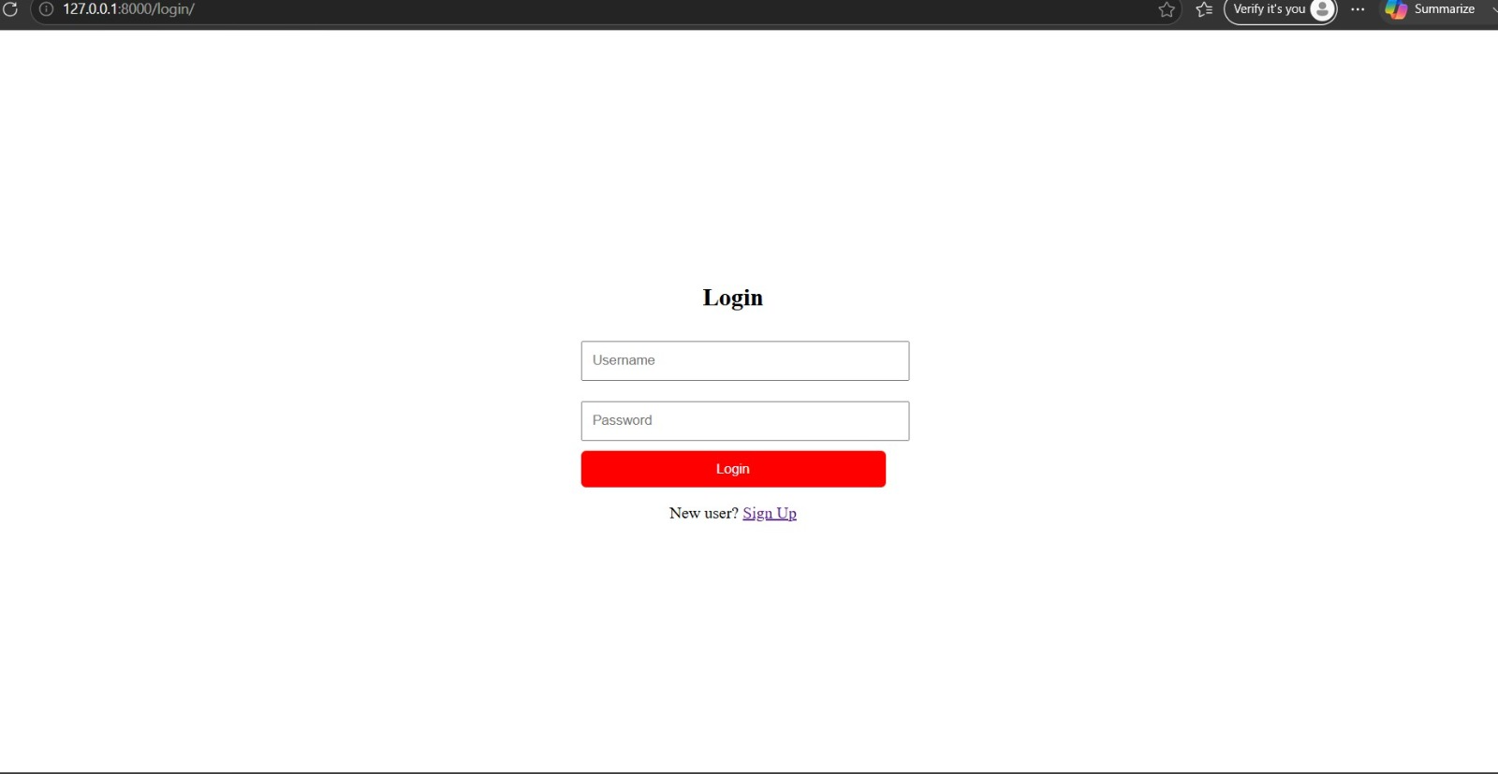
SIGNUP
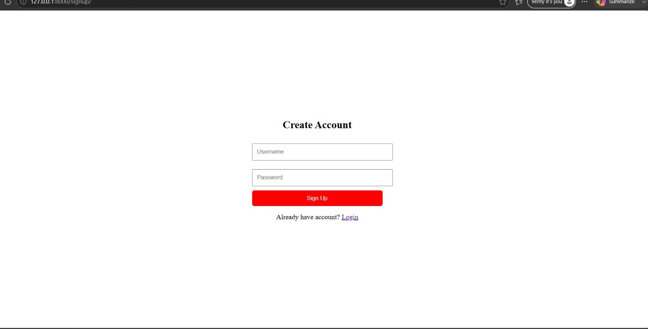
VIEW MOVIES
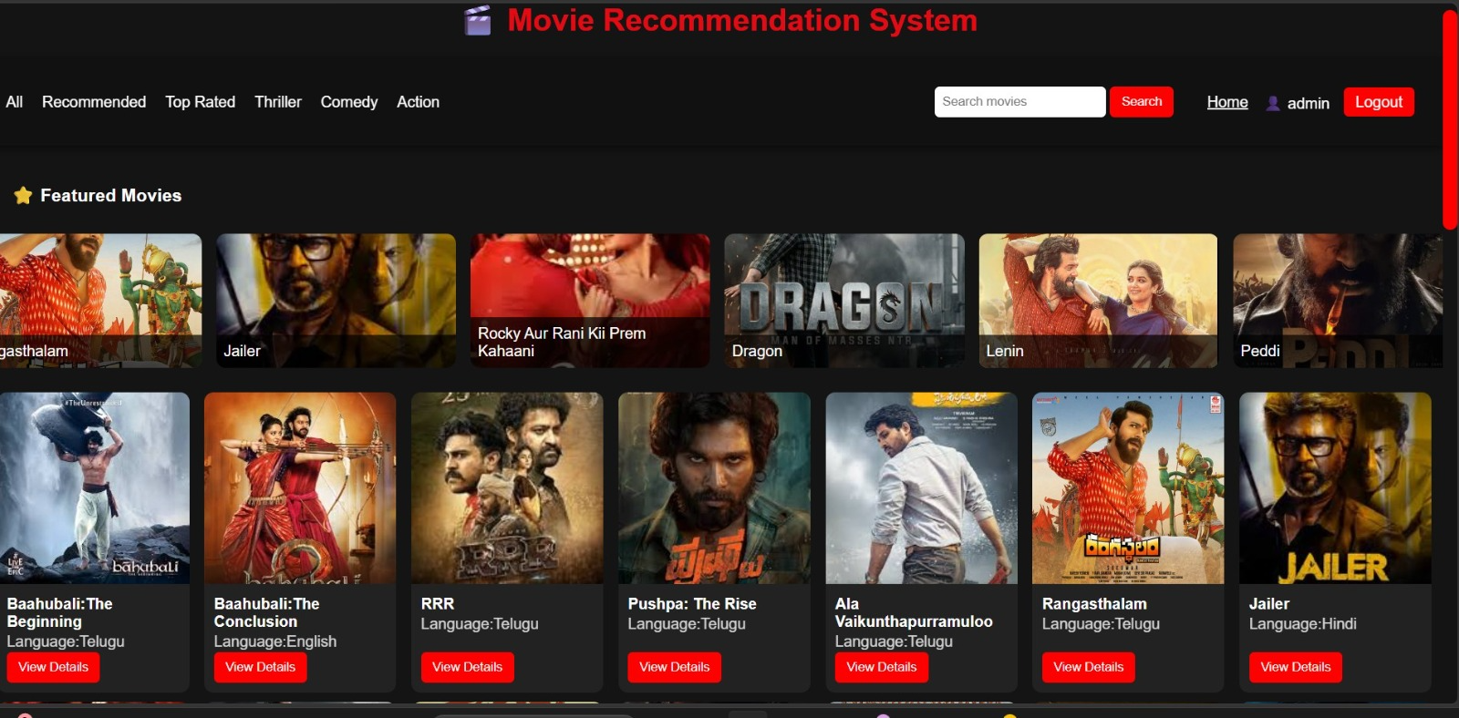
SEARCH MOVIES AND LOGOUT
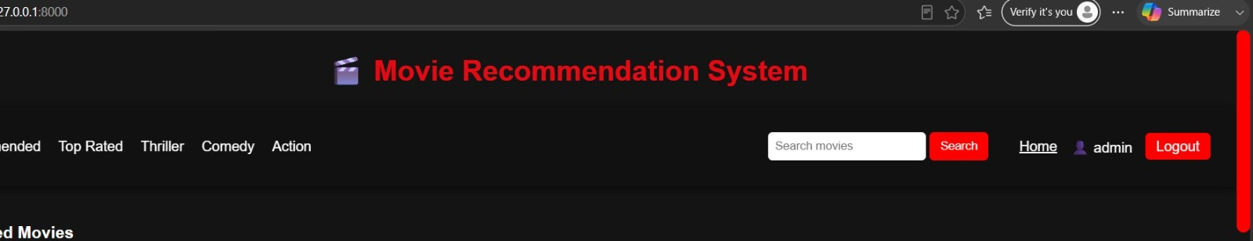
ADMIN LOGIN
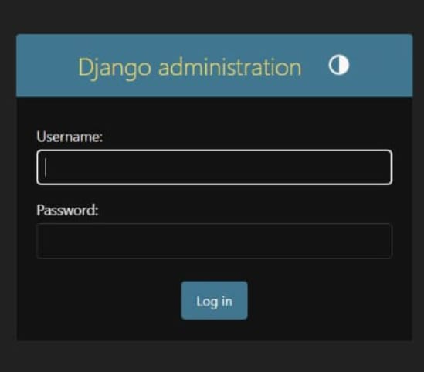

ADMIN PANEL
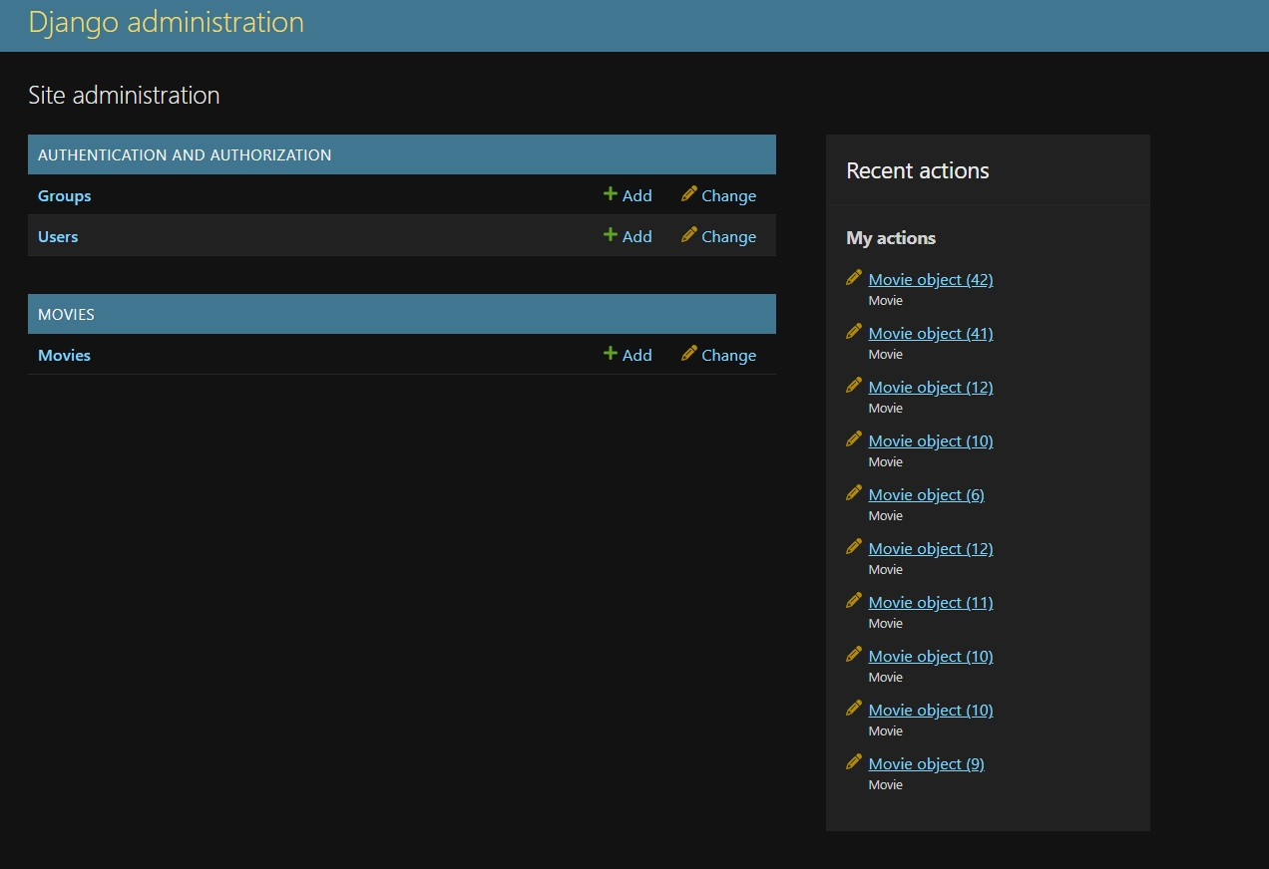

RESULT
The Movie Recommendation System was successfully developed using Python and Django. The system allows users to browse, search, and view movie details and provides recommendations based on movie genres and user preferences. The application works efficiently, offers a user-friendly interface, and helps users discover suitable movies quickly and easily.
CONCLUSION
The Movie Recommendation System developed using Python and Django successfully provides users with an easy and efficient way to discover movies based on their preferences. The system effectively manages movie data, offers personalized recommendations, and enhances the overall user experience. This project also demonstrates the practical application of web development and recommendation techniques using Python and Django.
FUTURE SCOPE
The Movie Recommendation System can be improved by integrating Machine Learning and Artificial Intelligence techniques to provide more accurate and personalized movie recommendations based on user preferences and viewing history.

